Disclaimer: I DO NOT claim or guarantee whether the answer written here is 100% accurate. If you feel something is not accurate or out-of-order or want to contribute, it will be a great help, if you let me know. Question which are crossed refers to the repeated question which has been answered already but this rule hasn’t been applied to all repeated question. Use Chrome to read this PDF properly. All question are from Pokhara University board exam papers of BCA.
Author: Pranav Bhattarai
Fall 2021
1 a) Distinguish between microeconomics and macroeconomics by examples.
1 b) Define indifference curve. Explain the customer’s equilibrium by indifference curve analysis.
2 a) Define price elasticity of demand. Compute price elasticity of demand form A to B and from C to D form the given table:
Point | A | B | C | D | E
Price(in Rs) | 10,000 | 20,000 | 30,000 | 40,000 | 50,000
Demand (in KG) | 5,000 | 4,000 | 3,000 | 2,000 | 1,000
2 b) Given the short run total cost function, C = 200+50Q-0.04Q+0.001Q³. Find TFC, AFC, AVC, AC and MC at 5 units of output levels.
3 a) Cob-Douglas production function is major theory of production. Explain.
3 b) How do firm and industry get equilibrium in monopoly market? Explain.
4 a) What is factor pricing? How price of a factor is determined in perfectly competitive factor market?
4 b) Define GDP and GNP. How national income is measured by product method? Discuss.
5 a) What is consumption function? Discuss various determinants of consumption function.
5 b) Define fixed exchange rate. How is exchange rate determined under flexible exchange rate system? Explain.
6 a) Discuss the objectives of monetary policy that affect the economic development of a country.
6 b) Discuss the major prospects of Economic Development in Nepal.
7. Write short notes on any two:
a) Tools of Fiscal policy
b) Principal of effective demand
c) Stages of business cycles

Fall 2019
1 a) Define Microeconomics. Explain the importance and uses of microeconomics.
Microeconomics is the study of individual firm, particular households, individual price, wage, the income of the industry and particular commodity. It is the process of determination of individual price with interaction with demand and supply.

Microeconomics study deals with what choices people make, what factors influence their choices and how their decisions affect the goods markets by affecting the price, the supply and demand.

The importance and used of microeconomics are enlisted below:
- Helpful in an efficient allocation of resources
Microeconomics efficiently allocates the resources. The microeconomic theory explains the condition of efficiency in both consumption and production that ensure maximum social welfare.
- Helpful in the study of human behavior
Microeconomics studies many diminishing forms of human behavior with the help of the law of diminishing marginal utility, indifference curve, etc.
- Helpful in formulating sectoral policies
There are different sectors such as industry, tourism, trade, and others. An understanding of each of these sectors is necessary before an appropriate policy is designed for them. Microeconomics provides a useful tool for the government while making sectoral decisions.
- Helpful to formulate economic polices
Microeconomics tools are used in designing price policy, taxation policy, and others in an economy dominated by the public sectors. It is also useful in designing the prices of public utilities in an economy.
- Helpful in business decision making
Microeconomics plays an important role in the business decision-making process. It guides the business managers in optimal resource utilization, demand analysis, cost analysis, optional production decision, and pricing policy.
- Helpful to understand the working of the economy
Microeconomics is helpful to understand the working of economy as it explains the functioning of a free enterprise economy. It tells us how millions of consumers and producers in an economy take decisions about the allocation of productive resources among millions of goods and services.
___________________________________________________________________________________________________________________________

1 b) Decompose the price effect in to substitution effect and income effect with the help of indifference curve in the case of normal good.
Solution:
A price effect represents change in consumer’s optimal consumption combination on account of change in the price of a good and thereby changes in its quantity purchased, price of another good and consumer’s income remaining unchanged. The consumer is better-off when optimal consumption combination is located on a higher indifference curve and vice versa.

A consumer's responses to a price change differ depending upon the nature of the good, viz. a normal good, inferior good or a neutral good. That are summarized in chart below:
Note

Price effect = Income Effect + Substitution Effect

This was study by two economist: Hicks and Slutsky

Both of them have their own method to calculate this.
Consumer real income means Consumer purchasing power.

Impact of fall in Price of Good X on its quantity demanded
Type of Price Effective | Nature of Good X | Quantity Demanded of Good X
Positive | Normal | Increases
Negative | Inferior | Decreases
Zero | Neutral | No Change
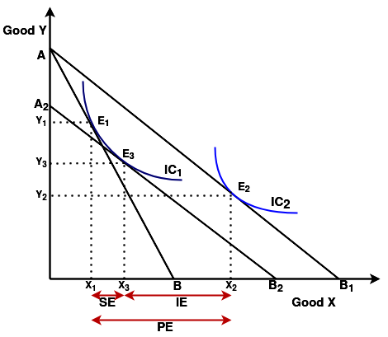
Price effect is positive in case of normal goods. There is inverse relationship between price and quantity demanded.

Now, with the help of indifference curve, we can decompose price effect in to substitution effect and income effect incase of ‘normal good’.

Here in this figure, there are two normal goods who are substitute of each other:
i) Good X ii) Good Y

We have three budget lines:
i) AB ii)AB₁ iii)A₂B₂

Things to note from graph is:
i) When price of good X decreases, the budget line AB shift to AB₁ because they want more good X, and want less good Y.

ii) A₂B₂ is compensating budget line to know whether the customer is getting same level of satisfaction which he/she was getting before. To do this, we need draw A₂B₂ parallel to AB₁ and it should touch same indifference curve IC₁.
Here,
SE = Substitution Effect
IE = Income Effect
PE = Price Effect
We know,
x₁x₂ = x₁x₃ + x₃x₂
∴ PE = SE + IE
______________________________________________________________________________________________________________________________

2 a) Define price elasticity of demand. Discuss about the different types of price elasticity of demand with their application.

Price elasticity of demand is an economic measure of the change in the quantity demanded or purchased of a product in relation to its price change. Expressed mathematically, it is:
Price Elasticity of Demand = % Change in Quantity Demanded
% Change in Price

There are five types of price elasticity of demand:
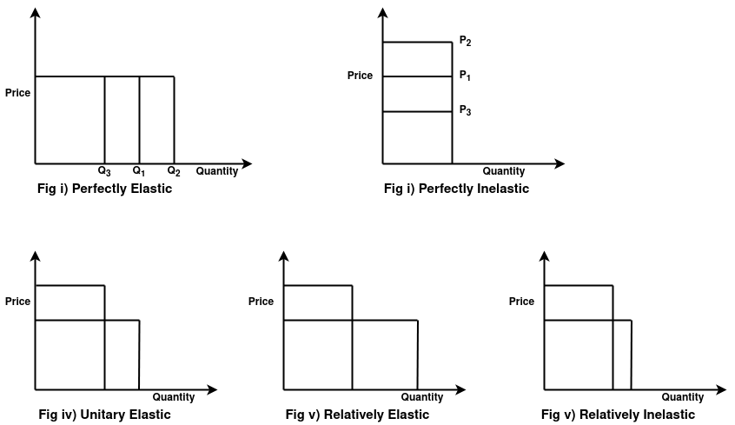
i) Perfectly elastic (E_{d} = ∞)
Quantity demanded changes even when price is constant.
(People are not gonna buy when producer increase price.)

ii) Perfectly inelastic (E_{d} = 0)
Quantity demanded remains constant whether price increase or decrease.
Example: Insulin

iii) Unitary Elasticity (E_{d} =1)
When price fall; Quantity demanded = Constant
When price rises; Quantity demanded = Constant

iv) Relatively elastic demand (E_{d} > 1)
When price fall; Quantity demanded = Increases
When price rises; Quantity demanded = Decreases
Example: Chocolate

v) Relatively inelastic demand (E_{d} < 1)
When price fall; Total revenue decreases.
When price rises; Total revenue increases.
Example: Petrol

__________________________________________________________________________________________________________________________

2 b) Define an opportunity cost. Given the short run total cost function, TC=100+60Q-120Q³. When Q=10, find: TFC, TVC, AFC, AVC, ATC and MC. (This is a bad question. Value of TC, AVC, ATC can never be negative.)

Ans:
Opportunity cost is the value of the next best alternative that is given up to engage in an activity or exchange.
Note

TFC = Total Fixed Cost
TVC = Total Variable Cost
AVC = Average Variable Cost
TFC = Total Fixed Cost
AFC = Average Fixed Cost
MC = Marginal Cost
Solution:
Given, TC = 100 + 60Q – 120Q³ -----------------(i)

We know, TC = TFC + TVC ------------------(ii)

Comparing eq(i) with eq (ii), we have:
TFC = 100
TVC = 60Q – 120Q³ ----------------(iii)
Formula

TC = TVC + TFC
AC = TC ÷ Q
TFC = AFC * Q
TVC = AVC * Q
AFC = TFC ÷ Q
AVC = TVC ÷ Q
ATC = AVC + AFC
MC = (TVC)_{n} - (TVC)_{n-1}
When putting Q = 10 in 3rd equation:
TVC = 60*10 – 120*10³ = 600 – 120,000 = (–) 119,400

Putting TVC & TFC value in 1st equation:
TC = 100 + (-) 119,400 = (–) 119,300

∴ AFC = TFC ÷ Q = 100 ÷ 10 = 10

∴ AVC = TVC ÷ Q = (-)119,400 ÷ 10 = (-) 119,40

∴ ATC = AVC + ATC = 10 + (-) 119,40 = (-) 119,30

∴ MC = (AVC)_{n} – (AVC)_{n-1} = - 119,40 – ((60*9-120*9³) ÷ 9) = -119,40 - (-86880 ÷ 9) = -119,40 + 9653.33 = (-) 21,593.33

_____________________________________________________________________________________________________________________________

3 a) Explain and illustrate the producer’s equilibrium with the help of a diagram in terms of cost minimization.

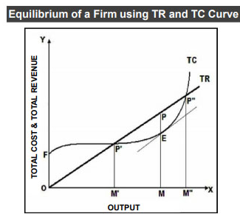
Equilibrium refers to a state of rest when no change is required. A firm (producer) is said to be in equilibrium when it has no inclination to expand or to contract its output. This state either reflects maximum profits or minimum losses.

There are two methods for determination of Producer’s Equilibrium:
i)Total revenue and Total Cost Approach (TR – TC Approach)
ii) Marginal Revenue and Marginal Cost Approach (MR – MC Approach)

TR – TC Approach
It has two conditions:
→ The difference between TR and TC is maximum
→ Even if one more unit of output is produced, then the profit falls. In other words, the marginal cost becomes higher than the marginal revenue if one more unit is produced.

MR – MC Approach
It has two conditions:
→ MR = MC
→ MC cuts the MR curve from below

============================================================================================================

3 b) Explain and illustrate the effect of indirect tax and subsides on the market equilibrium under perfect competition market.
------------------------------------------------------------------------------------------------------------
4 a) What do you mean by Linear programming? Discuss its essential components.

Linear programming is a method to achieve the best outcome (such as maximum profit or lowest cost) in a mathematical model whose requirements are represented by linear relationships.
Linear programming has thus helped to bridge the gap between abstract economic theory and managerial decision-making in practice.
Linear programming is considered as an important technique which is used to find the optimum resource utilization.

Essential components of liner programming are:
i) Decision Variables - These are the unknown quantities that are expected to be estimated as an output of the LP problem solution.

ii) Constraints - The limitations should be expressed in the mathematical form, regarding the resource.
(The restrictions or limitations on the total amount of a particular resource required to carry out the activities that would decide the level of achievement in the decision variables. In the standard form of a linear programming problem, all constraints are in the form of equations.)

iii) Data -

iv) Objective functions - In a problem, the objective function should be specified in a quantitative way.
(All linear programming problems aim to either maximize or minimize some numerical value representing profit, cost, production quantity, etc. It evaluates the amount by which each decision variable would contribute to the net present value of a project or an activity.)

The advantages of linear programming are:
i) It provides insights to the business problems.
ii) It helps to solve multi-dimensional problems.
iii) According to the condition change, LP helps in making the adjustments.
iv) By calculating the cost and profit of various things, LP helps to take the best optimal solution.

------------------------------------------------------------------------------------------------------------
4 b) Explain why the demand for a factor is a derived demand. Find out the market demand curve for labor under perfect competition market.
------------------------------------------------------------------------------------------------------------
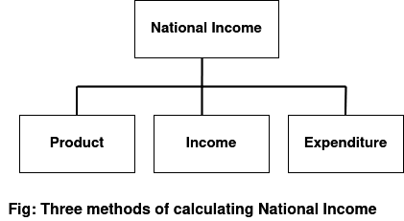
5 a) Define national income. Discuss the difficulties of the measurement of NI.
Total net value of all goods and services produced in a country within a specified period of time is called national income.

Difficulties of measurement of NI are:

i) Lack of reliable data
National income estimate is made on the basis of primary data relating to incomes and values of goods produced. It is observed that many producers —particularly petty producers and traders— do not maintain any accounts of their incomes and even goods produced. Obviously, the primary data collected from this source is supposed to be vague. The reason behind this is illiteracy. Further, many people are reluctant to cooperate with the data collectors. Above all, data collectors often ‘fabricate’ data even without approaching the door of producing sectors or economic units. If this information is considered to be the basis of judgment, then the judgment will suffer from inaccuracy.

ii) Existence of Non-Monetized sector (or Unpaid Services)
Non-monetary transactions such as services of housewives to member of their families teaching their own child, working in own farm, fruits and vegetables produced and consumed by household, etc.

iii) Difficulties of Classification of working population
Working population is not clearly defined. For example, agriculturists in Nepal are not engaged in agriculture round the year. Obviously, in off-season they engage themselves in alternative occupations. In such a case, it is very difficult to identify their incomes to a particular occupation.

iv) Illegal Income
Illegal forms of economic activity and illegal activities that are not reported to the authority. Gambling and drug trade are illegal forms of economic activities while people in power receive bribes but these people either under-report or do not report the bribed incomes that are illegal to avoid legal action.

v) Petty Production
There is a large number of petty production and it is difficult to include their production in national income because they do not maintain any account. Family members are engaged in the work and they don’t keep track flow of incomes & expenditure declaring the whole production as “local”.

vi) Illiteracy and Ignorance
If the majority of people are illiterate and ignorant, they don’t keep the records of production action activities accurately. Hence, it is difficult to get the correct information about the production.

vi) Problem of double counting
Only final goods and services are included in the national income accounting. But it is very difficult to distinguish between final goods and intermediate goods. For a steel manufacturing company, steel is their final product but same steel is intermediate goods for Car company.

vii) Problem in identifying Stock appreciation
viii) International Transactions
viii) Mixed Income
------------------------------------------------------------------------------------------------------------
5 b) The size of the multiplier varies directly with the size of marginal propensity to consume. Explain.
6 a) What do you mean by foreign direct investment (FDI)? Explain its role in the economic development of Nepal.
OR
Define economic development. Explain the major challenges and prospects of economic development of Nepal.

Challenges/problem of economic development of Nepal:-
Nepal's development is characterized by low incomes, increasing food deficits, increasing unemployment, persistent marginalization of women, widening gaps between rich and poor, growing dependency on foreign aid, persistent political instability and corruption. Since 1951 when the first donation of foreign aid came particularly from the United States, significant improvements have occurred. In infrastructure, an expansion of roads, schools, health centers and communication networks have happened. The economy has also undergone a transformation specifically in agriculture. Nevertheless, Nepal's development failure is apparent in its lack of sustainability and persistent dependence upon foreign aid. Nepal's long-term dependency has brought the growth of a now well-established development sector, the non-government organizations (NGOs) and the international non-government organizations (INGOs). Dysfunctionalism of the state has been recognized as the primary reason for the persistence of poverty and political instability. Governmental lethargy, inaction and corruption have been permanent features in Nepali politics. The notion of fatalism has a strong effect in Nepali politics and governance. The Maoist insurgency continues to hinder the development in Nepal. In general, the past fifty years of development efforts have resulted in minimal improvements.

Prospects/hope of economic development of Nepal:-
No one believed that the Kathmandu Valley would be load shedding-free before Kulman Ghising, managing director of Nepal Electricity Authority. Visionary Nepali youths have the caliber and creativity that can change the face of Nepal. In order to do this, youths have to go no further than their field. Agriculture in Nepal carries immense possibilities if done in the modern way.
Number of people creating DMAT account has skyrocketed. This means people are involving in Nepal share market to buy/sell share. This is a good thing to consider. The end result of this is developed of Nepal in one way or another.

Nepali youths should engage themselves in various sectors, instead of dreaming of going to foreign nations for employment. Mass agriculture production would bring down the exports, thus retaining business and hard earned money within the country.

Tourism is also one sector where we can do major improvement. We can work to spread the word that Nepal is the best hospitable travel destination and promote the country’s natural beauty so as to attract foreign visitors.

Another area that holds immense potential is hydro-electricity projects. Nepal has numerous small and big rivers, with the capacity of generating of as much as 83,000 megawatt electricity. If we could establish hydro projects, chances are that we can export power to other nations. With electricity comes business, so power generation could help open factories and industries within the nation.
Electricity can bring most Nepali’s troubles to an end, like load shedding, fuel cost, and travel cost. We could have electric trains, cable cars and other modes of electric transportation with the availability of abundant power. Power generation within the country will also reduce dependency on other nations.

____________________________________________________________________________________________________________________________

6 b) Distinguish between fixed exchange rate and floating exchange rate. Explain how foreign exchange rate in determined.
Ans:

Fixed Exchange Rate | Floating exchange rate
A fixed, or pegged, rate is a rate the government (central bank) sets and maintains as the official exchange rate. | A floating exchange rate is determined by the private market through supply and demand.
The investor will always know what his or her investment's value is and will not have to worry about daily fluctuations. | The investor won’t be so sure about his or her investment’s value since the value of exchange rate fluctuates on daily basis.
For a long run, fixed exchange rate is not considered safe because it is very difficult to maintain. In a worse case, it can lead to financial cries in the country. | For a long run, floating exchange rate is considered safe because any differences in supply and demand will automatically be corrected in the market.

Exchange rates can be either be fixed or floating.
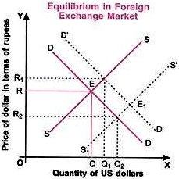
In fixed exchange rate, government set and artificially maintain their currency value. This rate will not fluctuate intraday and may be reset on particular dates known as revaluation dates. Governments of emerging market countries often do this to create stability in the value of their currencies. To keep the pegged foreign exchange rate stable, the government of the country must hold large reserves of the currency to which its currency is pegged to control changes in supply and demand.

Foreign exchange rate is determined based on demand and supply. Graphically, intersection of demand and supply curves determines the equilibrium exchange rate of foreign currency. At any particular time, the rate of foreign exchange must be such at which quantity demanded of foreign currency is equal to quantity supplied of that currency. It is proved with the help of the following diagram ------------------------------------------------------------------------>

If people demand of currency “A” is more, than the value of “A” increases. This is called currency appreciation. Similarly, if there is less demand of currency “B”, than its market exchange value decreases or remain constant. This is called currency depreciation. People always refer those currencies which give them higher returns.
______________________________________________________________________________________________________________________________

7) Write short notes on any two:
a) Objective of monetary policy
b) Phases of Business Cycle
______________________________________________________________________________________________________________________________

c) Effective demand
Effective demand refers to the willingness and ability of consumers to purchase goods at different prices. It shows the amount of goods that consumers are actually buying – supported by their ability to pay.

Effective demand excludes latent demand – where the willingness to purchase goods may be limited by the inability to afford it – or lack of knowledge.

In Keynes’s macroeconomic theory, effective demand is the point of equilibrium where aggregate demand = aggregate supply. The importance of Keynes’ view is that effective demand may be insufficient to achieve full employment due to unemployment and workers without income to produce unsold goods.

Demand curve showing individual’s effective demand
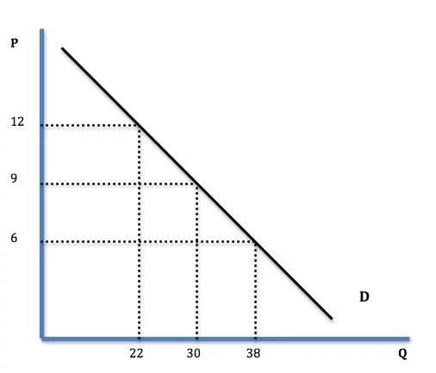
In this case, the consumer will be willing and able to purchase 22 goods when the price is £12.
Factors affecting effective demand are:
1. Price
2. Income – a rise in income will tend to cause rising demand.
Availability of credit. If consumers and firms are able to borrow, then they have an effective demand to buy or invest. If credit is constrained, their effective demand is limited by the lack of access to credit.
________________________________________________________________________________________________________________________________

2018 Spring
1 a) Explain the concept of micro statics and micro dynamics with suitable diagrams.

Micro-Dynamics is the branch of microeconomics which deals with two or more equilibrium and explains each and every steps of change in equilibrium from one static point to other. With the help of diagrams below, we can explain this more clearly.

_______________________________________________________________________________________________________________________
1 b) How price effect can be decomposed into substitution effect and income effect explain with the help of indifference curve analysis in case of normal goods.

2 a) Compute total cost, average variable cost, average cost and marginal cost out of the following information. The total fixed cost is 200. All cost are in the Rs. and quality of production is in Kg.
Quality of Production | 0 | 1 | 2 | 3 | 4 | 5 | 6 | 7 | 8
TVC | 0 | 50 | 90 | 120 | 140 | 175 | 230 | 310 | 400
Solution:
Given:
Total Fixed Cost (TFC) = 200
To find:
Total Cost (TC) = ? = TVC + TFC
Average variable Cost (AVC) = ? = TVC ÷ Q
Average Cost (AC) = ? = TC ÷ Q
Marginal Cost (MC) = ? = (TVC)_{n} - (TVC)_{n-1}

Using formula and given data, we can create this table: // In exam, directly write value inside table. Don’t write its calculating process.
Formula:

TC = TVC + TFC
AC = TC ÷ Q
TFC = AFC * Q
TVC = AVC * Q
AFC = TFC ÷ Q
AVC = TVC ÷ Q
ATC = AVC + AFC
MC = (TVC)_{n} - (TVC)_{n-1}
Q | TVC | TFC | TC | AVC | AC | MC
0 | 0 | 200 | 0 + 200 = 200 | – | – | –
1 | 50 | 200 | 50 + 200 = 250 | 50 ÷ 1 = 50 | 250 ÷ 1 = 250 | 50 – 0 = 50
2 | 90 | 200 | 90 + 200 = 290 | 90 ÷ 2 = 45 | 290 ÷ 2 = 145 | 90 – 50 = 40
3 | 120 | 200 | 120 + 200 = 320 | 120 ÷ 3 = 40 | 320 ÷ 3 = 106.67 | 120 – 90 = 30
4 | 140 | 200 | 140 + 200 = 340 | 140 ÷ 4 = 35 | 340 ÷ 4 = 85 | 140 – 120 = 20
5 | 175 | 200 | 175 + 200 = 375 | 175 ÷ 5 = 35 | 375 ÷ 5 = 75 | 175 – 140 = 35
6 | 230 | 200 | 230 + 200 = 430 | 230 ÷ 6 = 38.33 | 430 ÷ 6 = 71.66 | 230 – 175 = 55
7 | 310 | 200 | 310 + 200 = 510 | 310 ÷ 7 = 44.29 | 510 ÷ 7 = 72.85 | 310 – 230 = 540
8 | 400 | 200 | 400 + 200 = 600 | 400 ÷ 8 = 50 | 600 ÷ 8 = 75 | 400 – 310 = 90

______________________________________________________________________________________________________________________________

2 b) Define Revenue. Show the relationship among AR, MR and TR curves for a product under monopoly market.

==>
Revenue is money brought into a company by its business activities. It is used to calculate net income of the company.
Net-income = Revenue – Expenses
∴ Revenue = Net-income + Expenses

Revenue is also known as sales, or turnover.

Relation between AR, MR and TR curves for a product under monopoly market

Monopoly market is the market structure where there is single seller selling a unique product in the market.
It’s a market situation where one company owns all market share and can control prices and outputs of a product. In monopoly market, price of commodity is determined by the producer. So, firm is price maker and consumers are price taker. To increase the sale of output, producer must reduce the price of the commodity. On the basis of this concept we can derive TR, AR and MR curves.

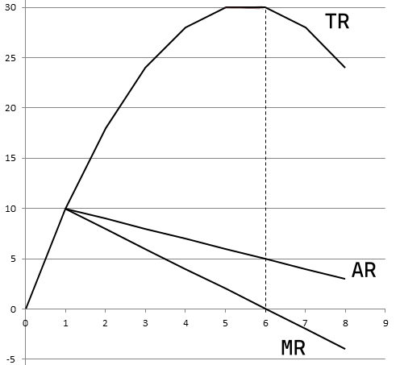
Using random number of quantities sold & its prices, we will calculate TR, AR & MR values and plot them in graph to draw curves and show the relation between them.

Q | P | TR = P * Q | AR = TR / Q | MR = ΔTR / ΔQ
1 | 10 | 10 | 10 | 10
2 | 9 | 18 | 9 | 8
3 | 8 | 24 | 8 | 6
4 | 7 | 28 | 7 | 4
5 | 6 | 30 | 6 | 2
6 | 5 | 30 | 5 | 0
7 | 4 | 28 | 4 | -2
8 | 3 | 24 | 3 | -4

Using above data we have draw all three curves as you can see –>

To show relationship between TC, AR and MR, we can say:

a) When AR is decreasing, MR should be decreasing faster than AR. Thus, downward sloping MR curve is below the downward sloping AR curve.
Things to note

AR = Average Revenue
MR = Marginal Revenue
TR = Total Revenue

b) MR can be negative, but AR can never be negative.

c) When TR curve start to move downward, MR curve starts to go negative.
---------------------------------------------------------------------------------------------------------

3 a) Enumerate the main features of Cobb-Douglas Production function.
3 b) What is market equilibrium? Show the effect of tax and subsidy upon market equilibrium price and quantity.
____________________________________________________________________________________________________
____________________________________________________________________________________________________

4 a) Why is the demand for factor input known as derived demand? Explain the modern theory of factor pricing.

Theory of Factor Pricing
is a economic theory which deals with the determination of the shared prices of all factors of production. Mainly, there are four factors involve in production, i.e. land, labor, capital and organization.

Share of land, is named as Rent.
Share of labor, is named as Wages.
Share of capital, is named as Interest.
Share of organization, is named as Profit.

This theory of factor pricing is also called theory of distribution. Because we are trying to distribute the production cost in form of rent, wages, interest and profit.

Rent is paid to landlord where a organization’s office or factory reside.
Wage is paid to labor, staff, manager, etc who were involved in production.
Interest is paid to bank where loan is issued to run the business organization & their production.
Profit is shared among owner, partners, shareholders and/or saved run to business.

Everything has its own value. Theory of factor pricing is really important to maintain the flow of money in core factors which are involved in production activities.

Although the value of the commodities and the prices of the factors of production are determined by the similar demand and supply concept but due to some differences in the factors of production on the side of supply, we need this separate theory.

____________________________________________________________________________________________________
____________________________________________________________________________________________________

4 b) Define national income. Discuss about the difficulties in the measurement of national income in countries like Nepal.
=========================================================================================================

5 a) Explain the principle of effective demand to determine level of employment.
===========================================================================================================
5 b) ‘Saving is private virtue but public vice’. Justify the statement.
=======================================================================================================
6 a) What do you mean by foreign direct investment (FDI)? Explain its role in economic development of Nepal.
OR
Define economic development. Explain the major challenges and prospects of economic development of Nepal.
6 b) Distinguish between fixed exchange rate and floating exchange rate. Explain how foreign exchange rate is determined in the market.
===========================================================================
7) Write short notes on any two:
a) Fiscal Policy
Fiscal policy is the means by which a government adjusts its spending levels and tax rates to monitor and influence a nation's economy. It is the sister strategy to monetary policy through which a central bank influences a nation's money supply. Using a mix of monetary and fiscal policies, governments can control economic phenomena.
=========================================================================
b) Business Cycle
=============================================================================
c) BIMSTEC
BIMSTEC is an international organization of seven nations of South Asia. It stands for The Bay of Bengal Initiative for Multi-Sectoral Technical and Economic Cooperation. The group formed in 1997 consists of Bangladesh, Bhutan, India, Nepal, Sri Lanka, Myanmar and Thailand.
_____________________________________________________________________________________________________________________________

2018 Fall
1 a) Define Micro and Macro Economics. Show three differences between them.

Macroeconomics is the study of all the units combined together or economy as in whole. It studies the economy in aggregate.
It studies national income, national output, general price label, total employment, total savings, total investment and so on.
It is also called “aggregate economic” or the “income theory”.

Three differences between them are:

Micro Economics | Macro Economics
i) It is the study of individual economic variable like demand, supply, price, etc. | It is the study of aggregate economic variable like aggregate demand, aggregate supply, price level, etc.
ii) It’s main objective is, “How to allocate scarce resources?”. | It’s main objective is, “How to achieve full employment?”.
iii) Laws and principles are based on assumption. | Laws and principles are far from assumption.

1 b) Explain and illustrate the customer’s equilibrium with the help of indifference Curve Analysis.

____________________________________________________________________________________________________________

2 a) Define an opportunity cost. Given the following TVC schedule and TFC is Rs. 200. Compute AFC, AVC, ATC, MC and TC.
Quality (in Kg) | 1 | 2 | 3 | 4 | 5 | 6 | 7
TVC (in Rs.) | 90 | 150 | 190 | 215 | 255 | 330 | 450
Ans:
Given,
TFC (Total Fixed Cost) = 200

Using table and formula, we can rewrite the table with all values as given below:
In exam, don’t calculate inside the table.
Formula:

TC = TVC + TFC
AC = TC ÷ Q
TFC = AFC * Q
TVC = AVC * Q
AFC = TFC ÷ Q
AVC = TVC ÷ Q
ATC = AVC + AFC
MC = ΔTVC

where, ΔTVC = (TVC)_{n} - (TVC)_{n-1}
Q | TVC | TFC | AFC | AVC | ATC | MC | TC
1 | 90 | 200 | 200 ÷ 1 = 200 | 90 ÷ 1 = 90 | 200 + 90 = 290 | – | 90 +200 =290
2 | 150 | 200 | 200 ÷ 2 = 100 | 150 ÷ 2 = 75 | 100 + 75 = 175 | 150 – 90 = 15 | 150 + 200 = 350
3 | 190 | 200 | 200 ÷ 3 = 66.67 | 190 ÷ 3 = 63.33 | 66.67+ 63.33 = 130 | 190 – 150 = 40 | 190 + 200 = 390
4 | 215 | 200 | 200 ÷ 4 = 50 | 215 ÷ 4 = 53.75 | 50 + 53.75 = 103.75 | 215 – 190 = 25 | 215 + 200 = 415
5 | 255 | 200 | 200 ÷ 5 = 20 | 255 ÷ 5 = 51 | 20 + 51 = 71 | 255 – 215 = 40 | 255 + 200 = 455
6 | 330 | 200 | 200 ÷ 6 = 33.33 | 330 ÷ 6 = 50 | 33.33 + 50 = 83.33 | 330 – 255 = 75 | 300 + 200 = 500
7 | 450 | 200 | 200 ÷ 7 = 28.57 | 450 ÷ 7 = 64.28 | 28.57 + 64.28 = 92.85 | 450 – 330 = 120 | 450 + 200 = 650
____________________________________________________________________________________________________________

2 b) Define total, average and marginal revenue. Show the relationship among, average and marginal revenue curve under imperfect competition market.

============================================================================================================
3 a) Define Cobb-Douglas production function. Explain its properties.
============================================================================================================
3 b) What is market equilibrium? Show the effect of tax and subsidy upon market equilibrium and price.

____________________________________________________________________________________________________________________________
4 a) Define factor pricing. Explain the modern theory of factor pricing.
___________________________________________________________________________________________________________________________
4 b) Define national income. Explain how national income is measured by expenditure method.

National income is measured by expenditure method by calculating two things:
i) Consumption expenditure
All those expenses done in household activities, government activities, company activities, etc are calculated here.

ii) Investment expenditure
Fixed capital investment while making/buying plant, building, machinery, etc are calculated here. All final goods of a company is mentioned here. We don’t include factor like raw materials because it can lead to double counting.

∴ National Income = C (household consumption) + G (government expenditure) + I (investment expense) + NX (net exports).

While calculating this, we need to also deduct depreciation on capital assets and indirect taxes.

=========================================================================================================
5 a) How the level of employment and output is determined according to Keynesian principle of effective demand? Illustrate with diagram.

____________________________________________________________________________________________________________________________

5 b) What is propensity to save? Explain the concept of Paradox of Thrift.
Propensity to save refers to the proportion of total income or of an increase in income that consumers save rather than spend on goods and services. The average propensity to save equals the ratio of total saving to total income; the marginal propensity to save equals the ratio of a change in saving to a change in income. The sum of the propensity to consume and the propensity to save always equals one.

Paradox of Thrift is a concept that was first presented by Bernard Mandeville in 1714. It was later popularized by John Maynard Keynes as one of the essential concepts in the study of macroeconomic theories.

It states that individuals try to save more during an economic recession, which essentially leads to a fall in aggregate demand and hence fall in economic growth. Such a situation is harmful for everybody as investments since it gives lower returns than in normal days. In this situation, mass increase in savings eventually hurts economy as a whole.

Although saving may be a virtue for an individual, but it is a vice for the public. It is because the expenditure of one person becomes the income of another. When one person saves, the income of another person declines.

The logical explanation behind saving being a vice is that, when aggregate saving increases, aggregate consumption decreases, causing a fall in the effective demand in the economy. Decrease in effective demand leads to over production in the market, and to maintain a balance, firms start producing less. It results in reduced investment. Similarly, decrease in effective demand reduces price as well as profit, discourages investment. Subsequently, there will be decline in employment, declining saving itself.

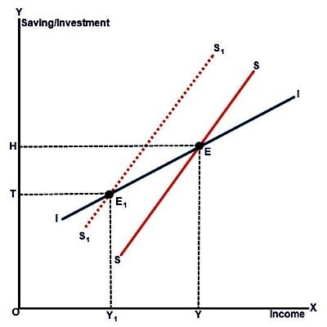
In this way, saving, which is beneficial at a personal level actually becomes disadvantageous at public and national level. This phenomenon is referred as the “paradox of thrift”.

This figure provides a clearer description of the concept. ---------------------------------------------------------------------→

In the figure, the point of equilibrium is at E where the saving curve SS and investment curve II intersect each other. The level of income at equilibrium is OY and saving and Investment are equal at OH.

When the aggregate saving increases, the saving curve shifts upwards from SS to S1S1. The new equilibrium point is E1 with OY1 level of income. Saving and investment are equal at point OT. As the level of saving increases, national income decreased from OY to OY1 . Similarly, the volume of saving and investment also declined from OH to OT.

This shows that an effort to save more has led to the decline in income and saving which is known as ‘Paradox of Thrift’.
____________________________________________________________________________________________________________________________

6 a) Explain the concept of privatization, liberalization and globalization in the context of Nepalese economy.
Nepal formally adopted the policy of liberalization, privatization and globalization after the restoration of multiparty democracy in the early 1990s as the forerunner of globalization in the South Asian region. The accession of Nepal to the WTO in 2004 accelerated the process of globalization. However, in the past two decades or so, Nepal has experienced a few success stories as well as cases of failure and frustrated expectations, which clearly highlight the need to assess the whole process of globalization.
Privatization
The transfer of ownership, property or business from the government to the private sector is termed privatization. The government stops from being the owner of the entity or business.
The process in which a publicly-traded company is taken over by a few people is also called privatization. The stock of the company is no longer traded in the stock market and the general public is barred from holding stake in such a company. The company gives up the name 'limited' and starts using 'private limited' in its last name.

Liberalization
Liberalization, the loosening of government controls. It refers to reductions in restrictions on international trade and capital. Liberalization is often treated as synonymous with deregulation—that is, the removal of state restrictions on business. In principle the two are distinct (in that liberalized markets can still be subject to government regulations—for example, to protect consumers), but in practice both terms are generally used to refer to the freeing of markets from state intervention.

Globalization
Globalization is the spread of products, technology, information, and jobs across national borders and cultures. In economic terms, it describes an interdependence of nations around the globe fostered through free trade.

On the upside, it can raise the standard of living in poor and less developed countries by providing job opportunity, modernization, and improved access to goods and services. On the downside, it can destroy job opportunities in more developed and high-wage countries as the production of goods moves across borders.

Nepal has gained some genuine benefits and opportunities from globalization, but in small areas. As economic reports and indicators reveal, the per capita GNI (Gross National Income) increased from $185 in 1990 to $721 in 2015 and the size of the GDP has expanded manifold since then. Furthermore, the extent of absolute poverty has reduced from 49 per cent to 23.8 per cent during that period. Though many factors may be responsible behind the historical transformation of Nepali economy, it would be prudent to analyze this phenomenon vis-a-vis globalization.

____________________________________________________________________________________________________________________________
6 b) What is adjustable ‘Peg’ System? How the rate of foreign exchange is determined under floating exchange system?
An adjustable peg is an exchange rate policy in which a currency is pegged or fixed to a major currency such as the U.S. dollar or euro but can be readjusted to account for changing market conditions. The periodic adjustments are usually intended to improve the country's competitive position in the export market.

A floating exchange rate is a regime where the currency price of a nation is set by the forex market based on its demand and supply relative to other currencies. The floating rate is usually determined by the open market through supply and demand. Therefore, if the demand for the currency is high, the value of that currency will increase. And if demand is low, the value of that currency decreases. A economic development also
____________________________________________________________________________________________________________________________
7) Write short notes on any two:

a) Objectives of monetary policy
Monetary policy is a set of economic policy that manages the size and growth rate of the money supply in an economy. It is a powerful tool to regulate macroeconomic variables such as inflation and unemployment.

The primary objectives of monetary policies are the management of inflation or unemployment, and maintenance of currency exchange rates.
___________________________________________________________________________________________________________

i) Inflation
Monetary policies can target inflation levels. The low level of inflation is considered to be healthy for the economy. However, if inflation is high, the monetary policy can address this issue.

ii) Unemployment
Monetary policies can influence the level of unemployment in the economy. For example, an expansionary monetary policy generally decreases unemployment because the higher money supply stimulates business activities that lead to the expansion of the job market.

iii) Currency exchange rates
Using its fiscal authority, a central bank can regulate the exchange rates between domestic and foreign currencies. For example, the central bank may increase the money supply by issuing more currency. In such a case, the domestic currency becomes cheaper relative to its foreign counterparts.
____________________________________________________________________________________________________________________________
b) Phases of Business Cycle
The Business Cycle refers to the ups and downs in the economic activities that the economy experiences over a period of time. Generally, the business cycle is the upward and downward movement in the level of GDP reflected by the fluctuations in the aggregate economic magnitudes Viz. Total production, employment, investment, wages, etc.
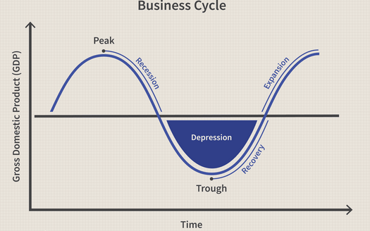
1. Expansion
This is the first stage. When the expansion occurs, there is an increase in employment, incomes, production, and sales. People generally pay their debts on time. The economy has a steady flow in the money supply and investment is booming.

2. Peak
The second stage is a peak when the economy hits a snag, having reached the maximum level of growth. Prices hit their highest level, and economic indicators stop growing. Many people start to restructure as the economy's growth starts to reverse.

3. Recession
These are periods of contraction. During a recession, unemployment rises, production slows down, sales start to drop because of a decline in demand, and incomes become stagnant or decline.

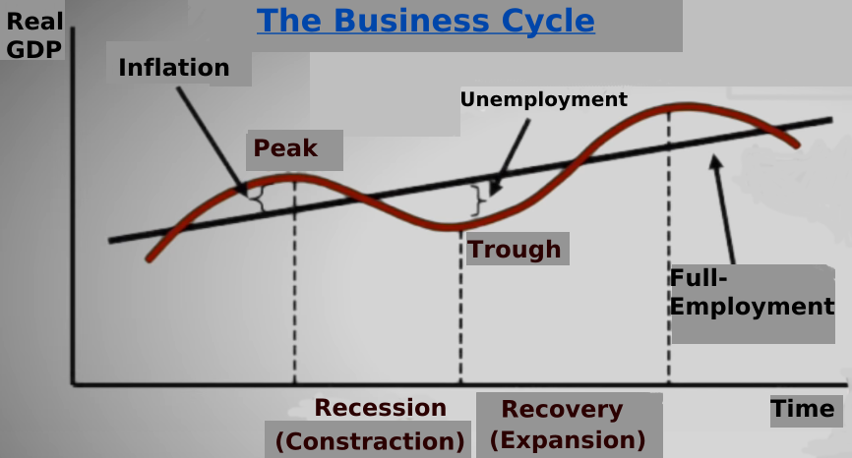
4. Depression
Economic growth continues to drop while unemployment rises and production plummets. Consumers and businesses find it hard to secure credit, trade is reduced, and bankruptcies start to increase. Consumer confidence and investment levels also drop.

5. Trough
This period marks the end of the depression, leading an economy into the next step: recovery.

6. Recovery
In this stage, the economy starts to turn around. Low prices spur an increase in demand, employment and production start to rise, and lenders start to open up their credit coffers. This stage marks the end of one business cycle.

____________________________________________________________________________________________________________________________

c) SAFTA
The South Asian Free Trade Area (SAFTA) is an agreement reached on January 6, 2004, at the 12th SAARC summit in Islamabad, Pakistan. It created a free trade area Afghanistan, Bangladesh, Bhutan, India, Maldives, Nepal, Pakistan and Sri Lanka to reduce customs duties of all traded goods to zero by the year 2016.

The SAFTA agreement came into force on January 1, 2006 and is operational following the ratification of the agreement by the seven governments. SAFTA required the developing countries in South Asia (India, Pakistan and Sri Lanka) to bring their duties down to 20% in the first phase of the two-year period ending in 2007. In the final five-year phase ending in 2012, the 20% duty was reduced to zero in a series of annual cuts. The least developed nations in South Asia (Nepal, Bhutan, Bangladesh, Afghanistan and Maldives) had an additional three years to reduce tariffs to zero. India and Pakistan ratified the treaty in 2009, whereas Afghanistan as the 8th member state of the SAARC ratified the SAFTA protocol on 4 May 2011.

→ To remove out all barriers in trade.
→ To develop the multiple trade system in SAARC countries.
→ To protect the industrial right.
→ To promote the fair competition market.
_______________________________________________________________________________________________________________________________________
Notes:

- According to MC. Connel, “In microeconomics, we examine the trees, not the forests.”

- Microeconomics is also called as “price theory” or “demand and supply theory”. Because it helps to determine price of the product and factor inputs.

- There are three type of microeconomics:
  - Micro-Statics
  - Comparative Micro-Static
  - Micro-Dynamics
____________________________________________________________

Indifference Curve
is a graph showing combination of two goods that gives the consumer equal satisfaction and utility. Each point on an indifference curve indicates that a consumer is indifferent between the two and all points give him the same utility.

IC is a locus point on a graph each representing a different combinations of two substitute goods, which yields the same utility or level of satisfaction to a consumer. The combination of goods give equal satisfaction to a consumer.

Therefore, a consumer is indifferent between any competition of two goods when it comes to making a choice between them. When these combination are plotted on the graph, the resulting curve is called the indifference curve. This curve is also called an equal utility curve.

____________________________________________________________
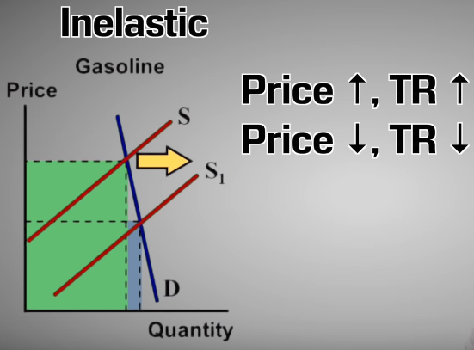
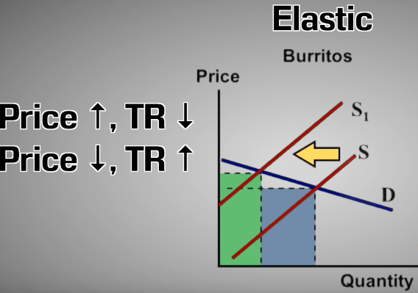
Elasticity of demand = % Change in Quantity
% Change in Price
where,
% Change in Quantity = Current quantity - Initial quantity * 100
Initial quantity

% Change in Price = Current price – Initial price * 100
Initial price

Net exports - the annual difference between a country's exports and imports.

Trade surplus - when a country exports more than it imports.

Trade deficit - when a country imports more than it exports.
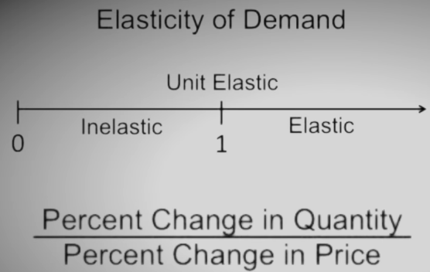
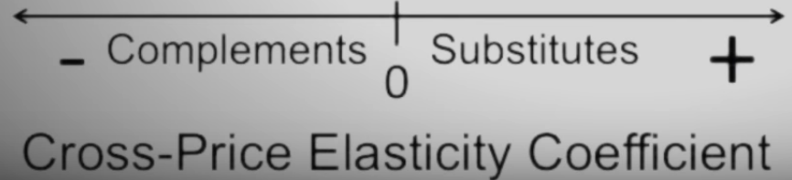
Protectionism - Placing high tariffs on imports and limiting the number of foreign goods to protect local businesses. Limited by the WTO or World Trade Organization.

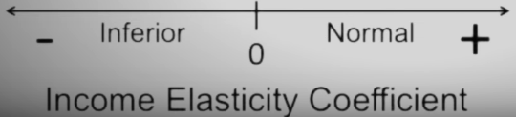
Foreign exchange (aka FOREX)

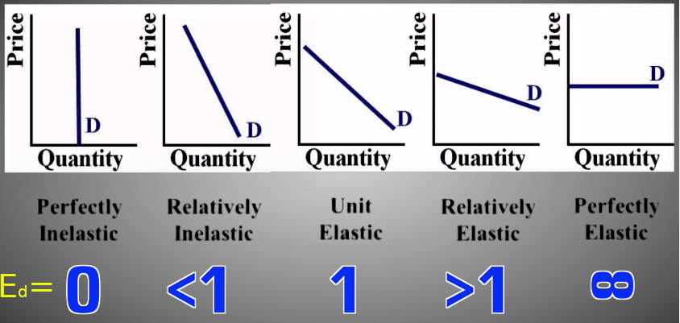
--------------------------------------------------------

Marginal Rate of Substitution
is a amount of good that a customer is willing to give up for another good, as long as the new good is equally satisfying.
MRS_{xy} = Δy ÷ Δx

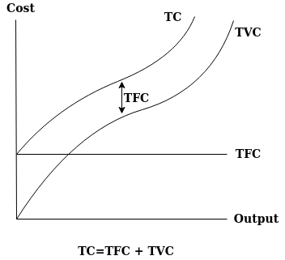
_________________________________________________________________

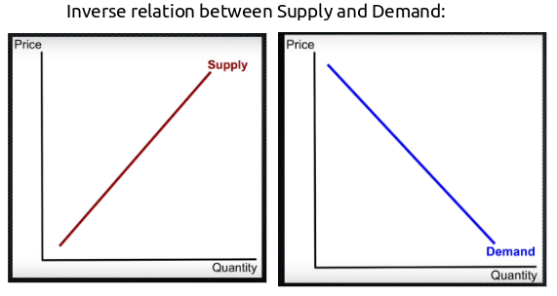
Two approach to study consumer behavior:

i) Ordinal approach
It uses indifference curve for analysis.
More realistic.
Use qualitative approach.
Promoted by modern economist.

ii) Cardinal approach
It uses marginal utility curve for analysis.
Less realistic.
Use quantitative approach.
Promoted by classical & Neo-classical economist.

